SET 9 – ONLINE LEARNING ACTIVITY ANALYSIS
Ayesha Siddiqa S - 04
192324305

Dataset: Online_Learning_Activity.csv
Student_ID | Gender | Age | Course | Study_Time | Videos_Watched | Quiz_Score | Login_Date
L01 | Male | 20 | R | 3.5 | 12 | 78 | 2025-01-05
L02 | Female | 22 | R | 4.2 | 15 | 85 | 2025-01-05
L03 | Male | 19 | SQL | 2.0 | 8 | 65 | 2025-02-08
L04 | Female | 21 | R | 5.0 | 18 | 92 | 2025-02-08
L05 | Male | 23 | R | 2.5 | 9 | 70 | 2025-03-12
L06 | Female | 20 | SQL | 4.0 | 14 | 88 | 2025-03-12

Question 1: Histogram and Boxplot of Quiz Scores
Aim
To analyze the distribution of quiz scores and compare quiz scores between different courses using R.
Algorithm
- Import the CSV dataset.
- Create a histogram using Quiz_Score.
- Create a boxplot using Course and Quiz_Score.
- Add title and axis labels.
- Interpret the distribution and performance.
R Code
# Import dataset
data <- read.csv("Online_Learning_Activity.csv")

# Histogram
hist(data$Quiz_Score,
main = "Distribution of Quiz Scores",
xlab = "Quiz Score",
ylab = "Frequency")

# Boxplot
boxplot(Quiz_Score ~ Course,
data = data,
main = "Quiz Score by Course",
xlab = "Course",
ylab = "Quiz Score")
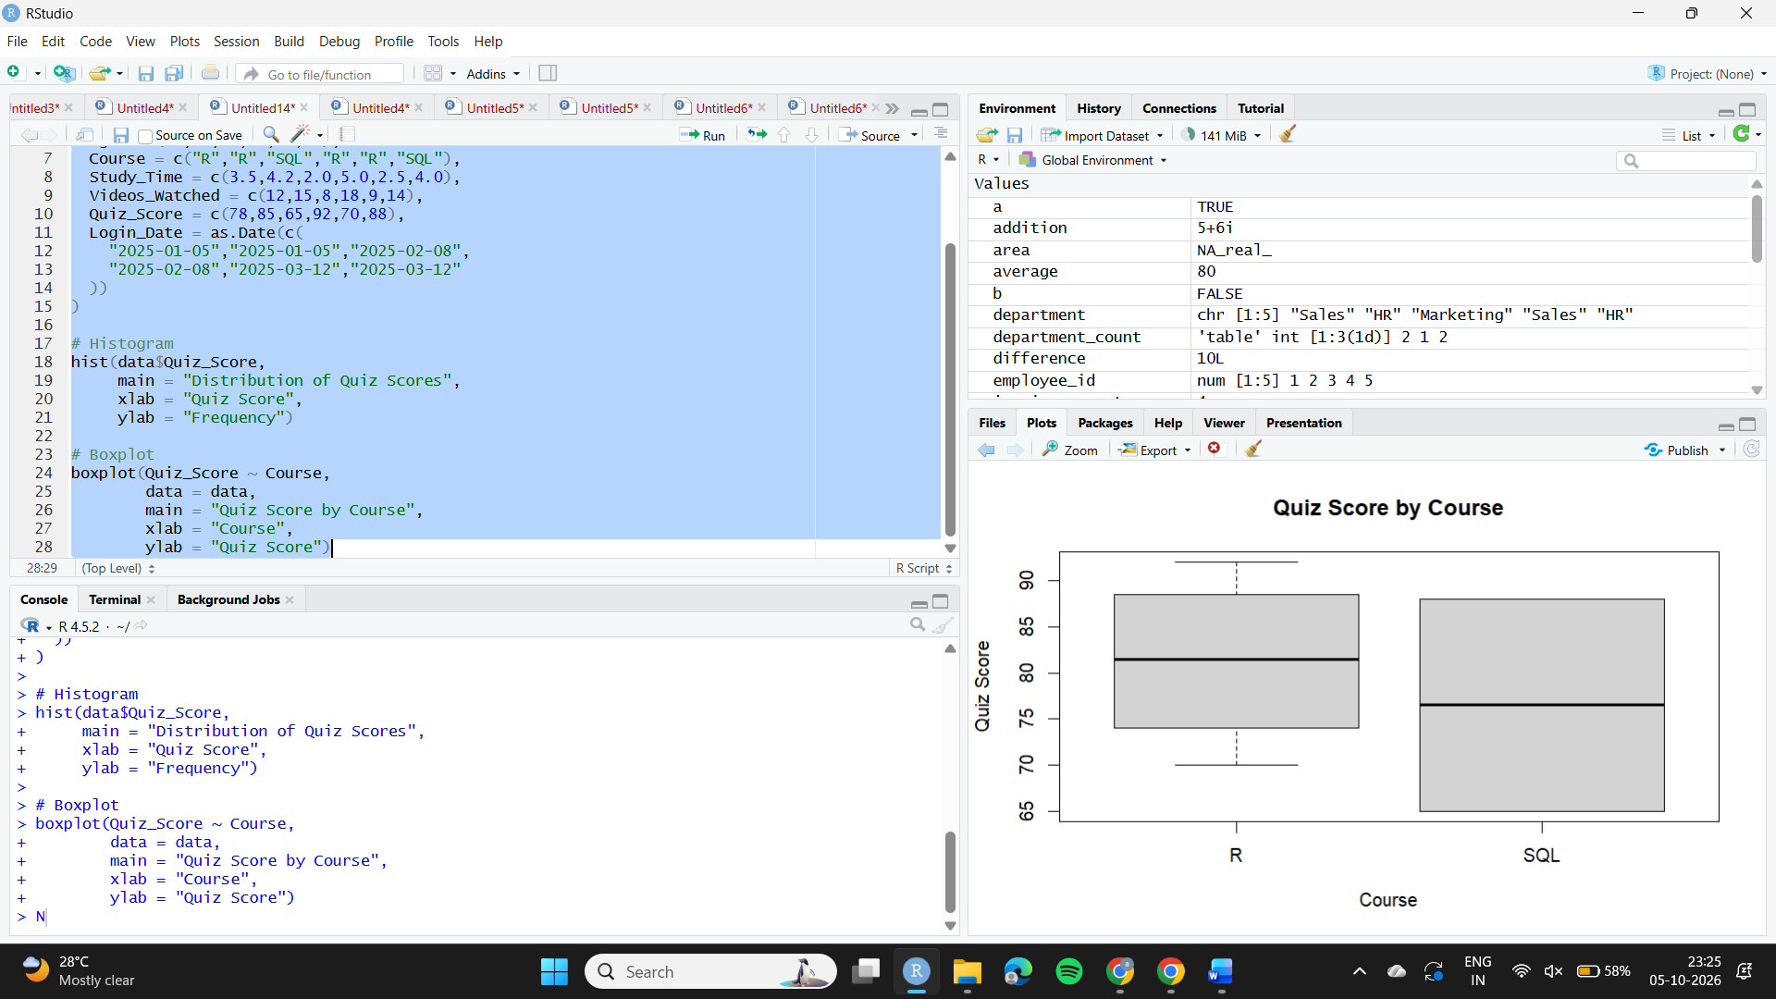
Observation
The quiz scores range from 65 to 92. The R course generally has higher scores, while SQL shows more variation because its scores are 65 and 88.

Question 2: Scatter Plot Between Study Time and Quiz Score
Aim
To analyze the relationship between study time and quiz score while representing the number of videos watched using bubble size.
Algorithm
- Put Study_Time on the X-axis.
- Put Quiz_Score on the Y-axis.
- Use Videos_Watched to control bubble size.
- Apply transparency to the bubbles.
- Analyze the relationship.
R Code
plot(data$Study_Time,
data$Quiz_Score,
cex = data$Videos_Watched / 4,
pch = 19,
col = rgb(0, 0, 0, 0.45),
xlab = "Study Time (hours)",
ylab = "Quiz Score",
main = "Study Time vs Quiz Score")
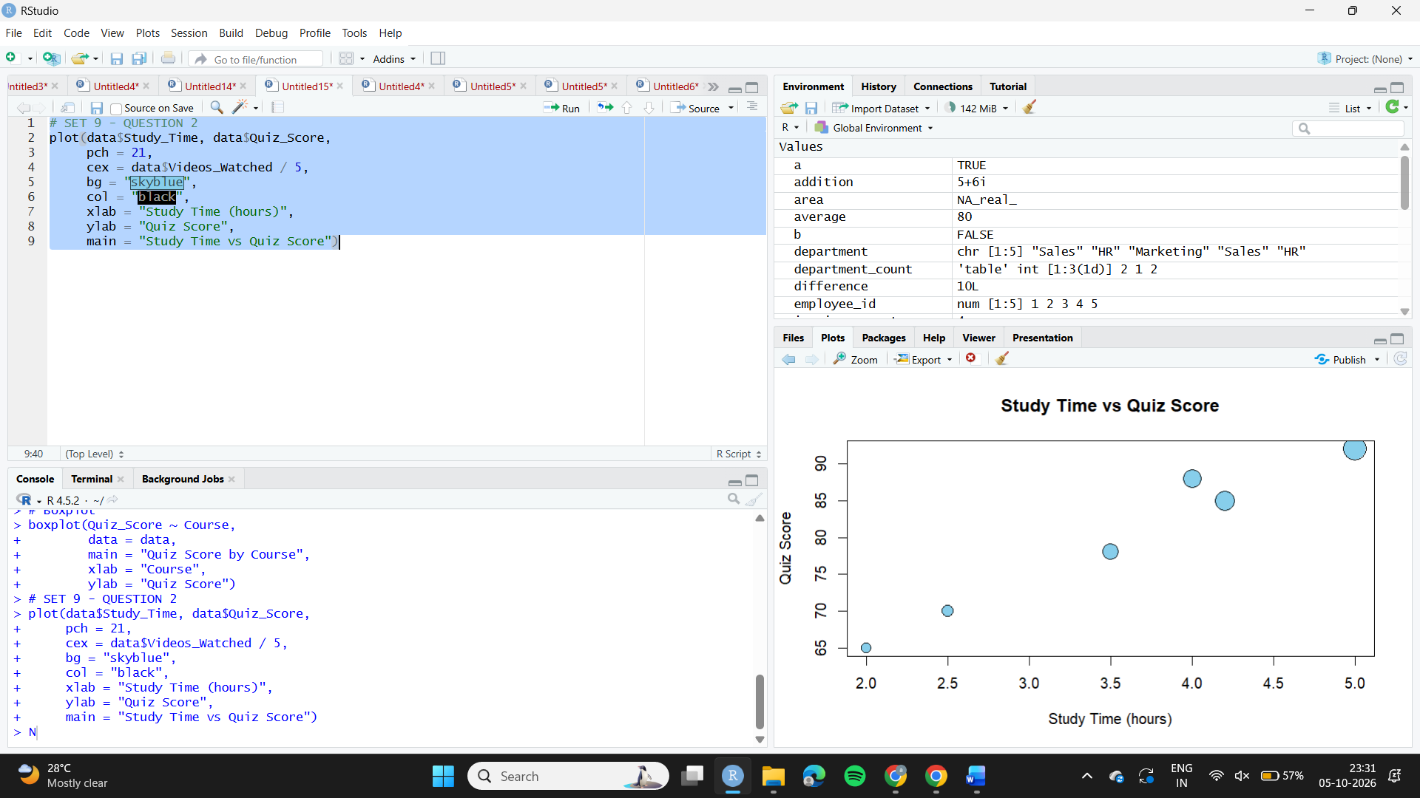
Observation
The scatter plot shows a generally positive relationship between study time and quiz score. Students who spend more time studying tend to achieve higher quiz scores. Larger bubbles represent students who watched more videos.

Question 3: Average Quiz Score Per Month with Moving Average
Aim
To convert Login_Date into Date format, calculate the average quiz score per month and identify the trend using moving-average smoothing.
Algorithm
- Convert Login_Date into Date format.
- Extract the month from the date.
- Calculate the average quiz score for each month.
- Calculate moving average.
- Plot the monthly average and smoothed trend.
R Code
# Convert Login_Date into Date format
data$Login_Date <- as.Date(data$Login_Date)

# Extract Year-Month
data$Month <- format(data$Login_Date, "%Y-%m")

# Calculate monthly average
monthly <- aggregate(Quiz_Score ~ Month,
data = data,
mean)

# Calculate moving average
monthly$Moving_Average <- stats::filter(
monthly$Quiz_Score,
rep(1/2, 2),
sides = 1
)

# Plot monthly average
plot(monthly$Month,
monthly$Quiz_Score,
type = "o",
xlab = "Month",
ylab = "Average Quiz Score",
main = "Average Monthly Quiz Score")

# Add moving average
lines(monthly$Month,
monthly$Moving_Average,
type = "o",
lty = 2)
Monthly Average
Month | Average Quiz Score
January 2025 | 81.5
February 2025 | 78.5
March 2025 | 79.0
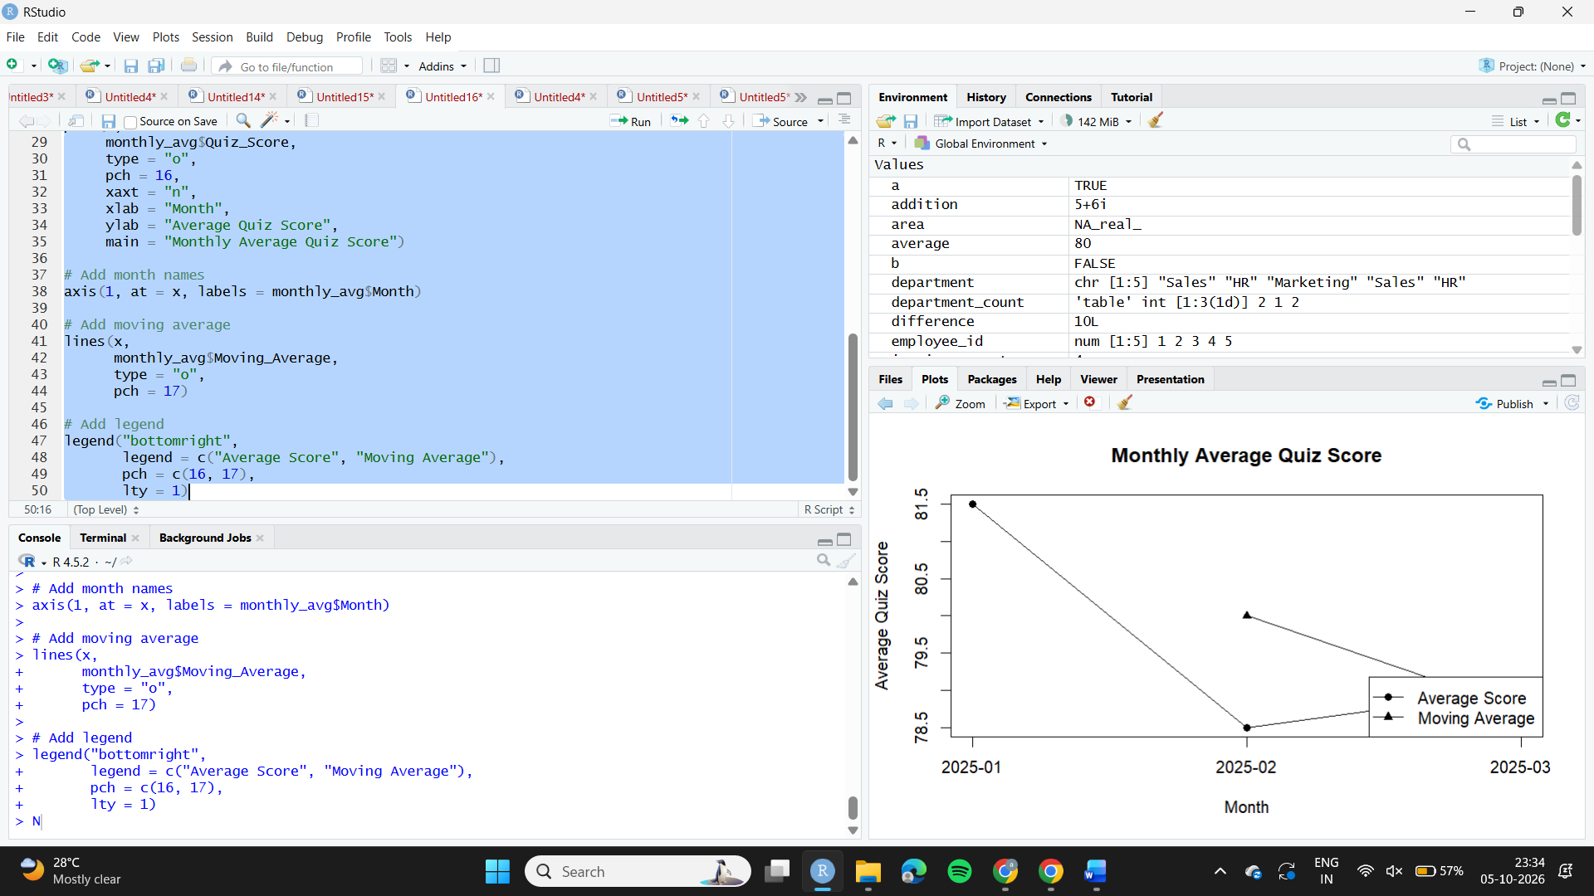
Observation
The average quiz score decreased from January to February and then showed a small increase in March. The moving average smooths the month-to-month variation and helps identify the overall trend.

Question 4: Tableau Interactive Dashboard
Aim
To create a mini interactive dashboard for analyzing online learning activity.
Algorithm
- Import Online_Learning_Activity.csv into Tableau.
- Create a bar chart of average quiz score by course.
- Create a scatter plot of Study Time vs Quiz Score.
- Add Gender and Course filters.
- Combine the charts into a dashboard.
- Format the dashboard for easy interaction.
Tableau – Bar Chart
Columns: Course
Rows: AVG(Quiz_Score)
Title: Average Quiz Score by Course
Tableau – Scatter Plot
Columns: Study_Time
Rows: Quiz_Score
Marks: Circle
Filters
Add:
- Gender
- Course
Observation
The Tableau dashboard allows users to compare the average quiz scores of R and SQL students and examine the relationship between study time and quiz performance. The Gender and Course filters provide interactive exploration of the dataset.

